Asia-China-Shang-Bronze-Tiger eating man-Final

Shang wine vessel, you虎食人卣

NAME:虎食人卣,You

SORT: Cooking Food Ware

MATERIAL: Bronze

LENGTH: 22.5CM/8.86Inches

HEIGHT: 34CM/13.39Inches

CONDITION: Rust on the body, museum quality

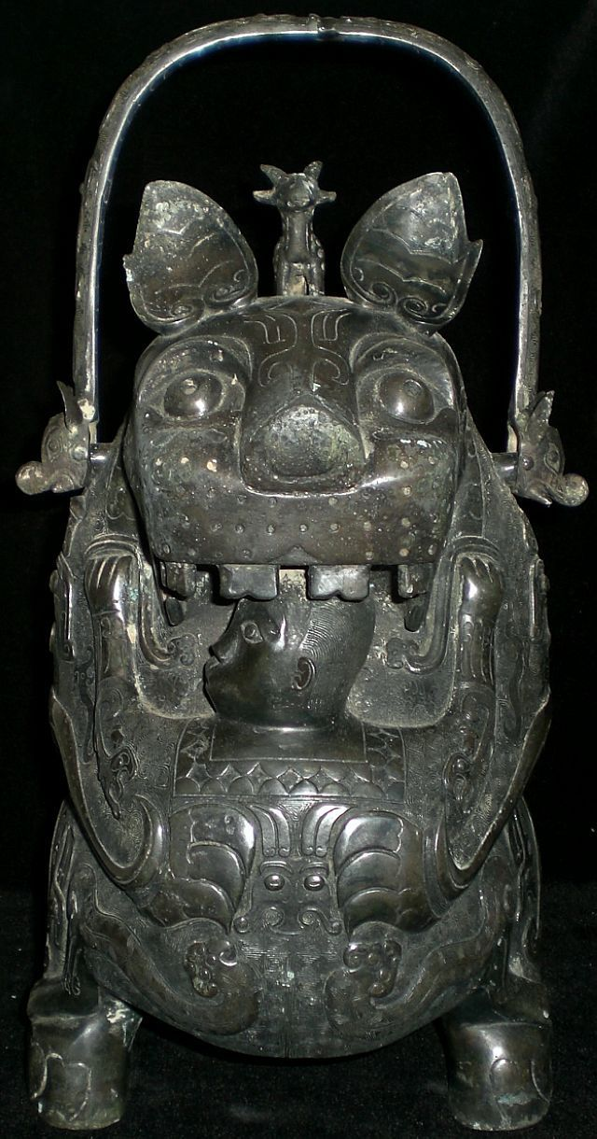

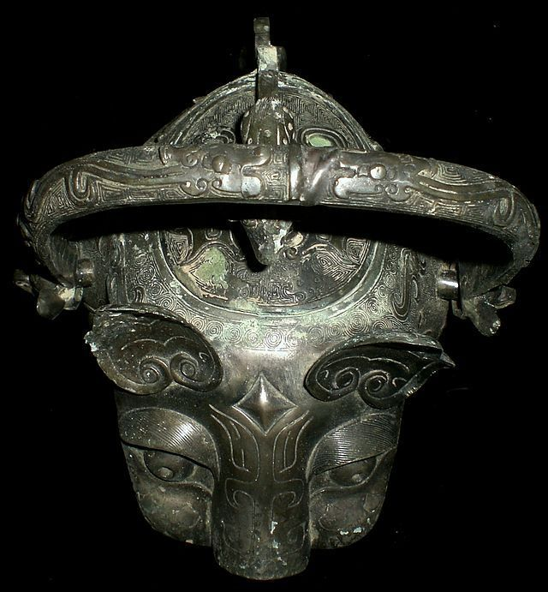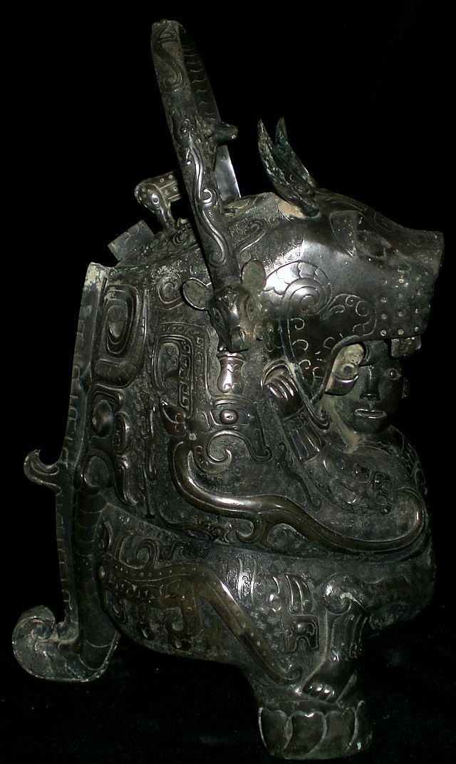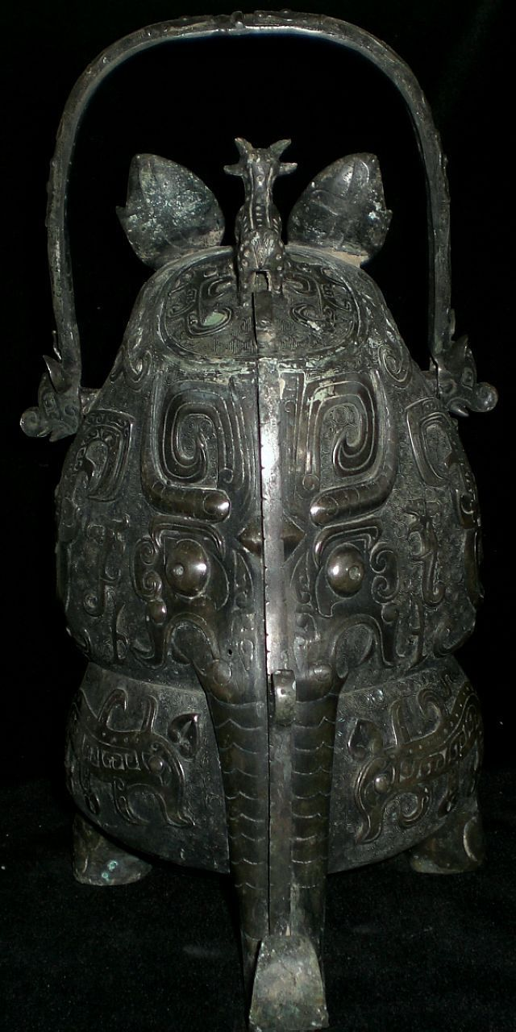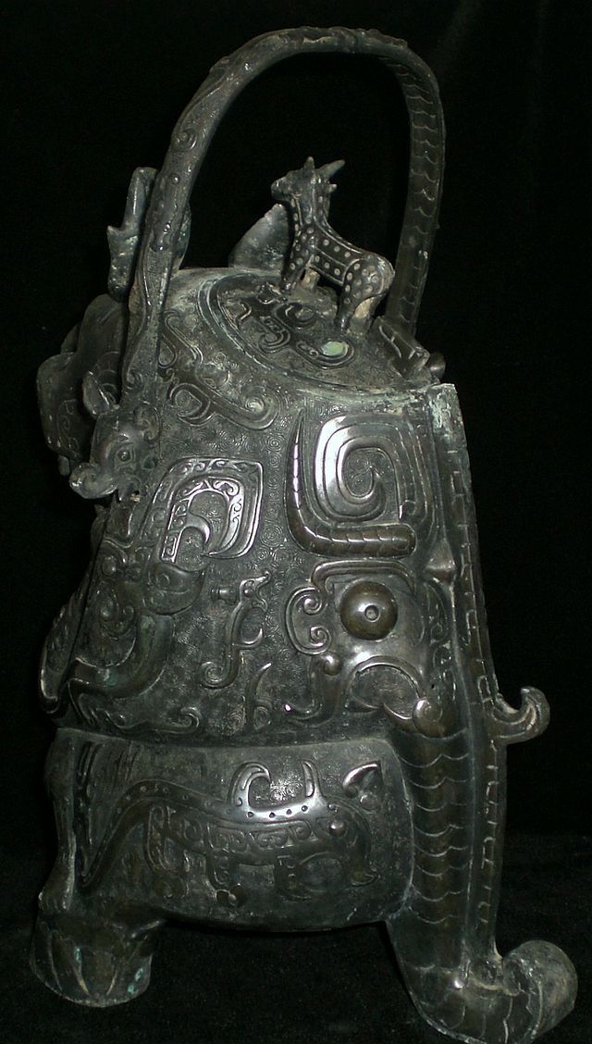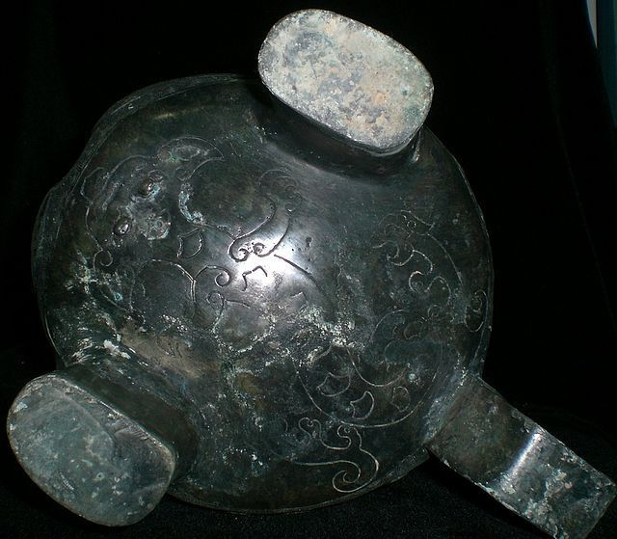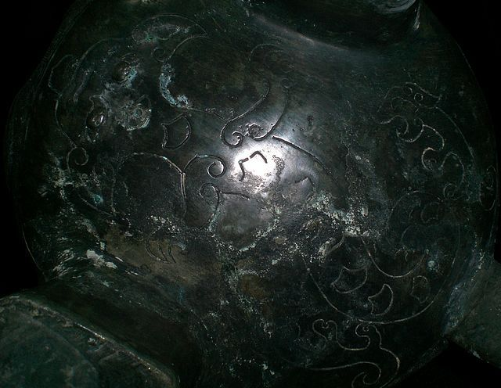

Bronze casters mark 

The tiger (hu 虎) is one of the twelve animals of the Chinese zodiac and is considered the ruler of the beasts on Earth as opposed to the dragon which rules the beasts in the sky and heavens.  
  
The tiger was perceived to be a symbol of protection: the word for tiger (hu) is also a pun because it has the same pronunciation as the word "protect" (hu 护). In ancient China, the tiger was the Guardian Spirit of Agriculture which could devour the Drought Demon.

The *you* bronze vessel called "Hushiren" ("Tiger Eats Man") is the bronze treasure of the Late Shang of China. There were two pieces found the first place, one is preserved in the museum of Japan while the other is in Paris Municipal Oriental Gallery of France. "Eating-man-tiger" reflects the myth of spirit-eating-tiger, that is, the ancients in primeval society used the brave and fierce tiger to drive away the evil spirits.   
  
Another name for this bronze vessel is *"ruhu"* - "milk-feeding tiger".   
  
It is shaped like a tigress holding a small human who is hugging a feline, while his head is placed under the mouth of the animal. The person's head is facing the tiger's wide open mouth, and it t seems that the tiger intends to eat the head of the man, but at the same time the person turns his head to one side and his face expression doesn't show any fear.   
  
The theme of a feline joined with a human figure, although present during the Shang Kingdom, is more common in the South China. It could be linked to a legend described in the Zuozhuang, an ancient commentary in the Spring and Autumn Annals (8th – 5th century B.C.) which tells the story of the grandson of Ruoao, born in the Chu Kingdom, named Ziwen who as a baby was rescued and raised by a tigress.   
  
The calm expression on the person’s face and the confident manner in which his feet rest on the feline’s paws give credit to this explanation. This legend is part of the totemic narratives that establish the origins of many aristocratic clans, bringing together man and beast in a protective relationship or through a sexual union that leads to the birth of a mythical ancestor of the Hu Kindom of the Shang Dynasty.   
  
The archaeological context behind the discovery of this piece is unknown. However, such designs were predominant features of Shang dynasty bronze art and artifacts. This artifact is complexly made which shows the excellent skill of casting art. Most of the surface patina on it. As the same as the majority of the bronze statues of late Shang, it has elaborate and complex decorations and takes the man and beast as the motif. The lower part of the *you* and the tiger's tow front paws and tail form three supporting points. There is an oval-square opening on the back of the tiger with a lid where a small dragon stands on. The prolific decoration on the dark green bronze, consisting of large animal motifs, stands out against a background of square spirals and kuilong, snakes and cloud and lightening patterns, is also characteristic of the Shang Era.   
  
What it expresses - tiger eats or feeds man - remains mystery, it's up to you to decide.  
  
Such bronze vessels served as a key instruments in aiding shamans in communicating between heaven and earth, or between ancestral spirits and other deities and living people. Symbolism and ritual status of "Tiger & Man" *you* vessel reflects the legendary powerful pantheon of ancient Chinese mythology and cosmology.

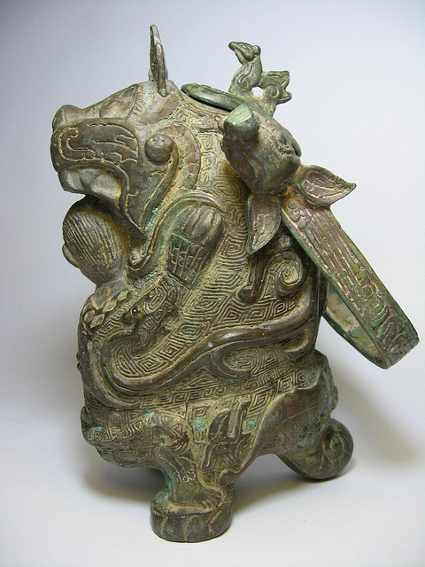 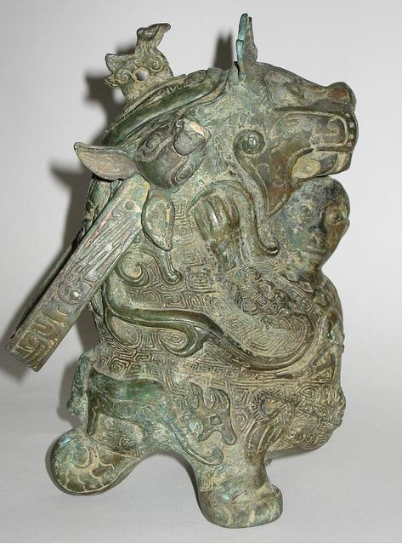 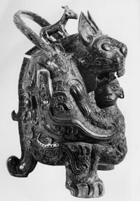

Ritual 'Yeou' vase known as 'The Tigress', detail, late Shang Dynasty, early 11th century BC (bronze) (see also 382541 and 170248)

Image ID: BCT 382542

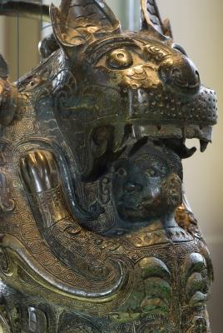

**Credit:** Ritual 'Yeou' vase known as 'The Tigress', detail, late Shang Dynasty, early 11th century BC (bronze) (see also 382541 and 170248), Chinese School, Shang Dynasty (1766-1050 BC) / Musee Cernuschi, Paris, France / Photo © Jacopo Brancati / The Bridgeman Art Library

|  |
| --- |
| BCT 382542  Image number: |
| Ritual 'Yeou' vase known as 'The Tigress', detail, late Shang Dynasty, early 11th century BC (bronze) (see also 382541 and 170248)  Title: |
| [Chinese School, Shang Dynasty (1766-1050 BC)](http://www.bridgemanart.com/search/artist/Chinese-School-Shang-Dynasty-1766-1050-BC/29483)  Primary creator: |
| Chinese  Nationality: |
| [Musee Cernuschi, Paris, France](http://www.bridgemanart.com/search/location/Musee-Cernuschi-Paris-France/3169) |

